Course Name | ITD 2343 – Object Oriented Programming with C#
Instructor | Mark L. Pranger
Student Name | Eric Christensen
Due date | Nov 7, 2025
Grade | <grade earned here>
Grading Comments | <instructor comments here>

Week 9 – Programming Lab

Screen Shots needed for Submission:

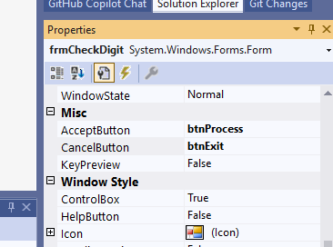

- Make a screen shot for each of the following points in the creation process
  - The form after you have completed all the visual changes specified in the UI design. many of the changes will not show in a screen shot but the color change will
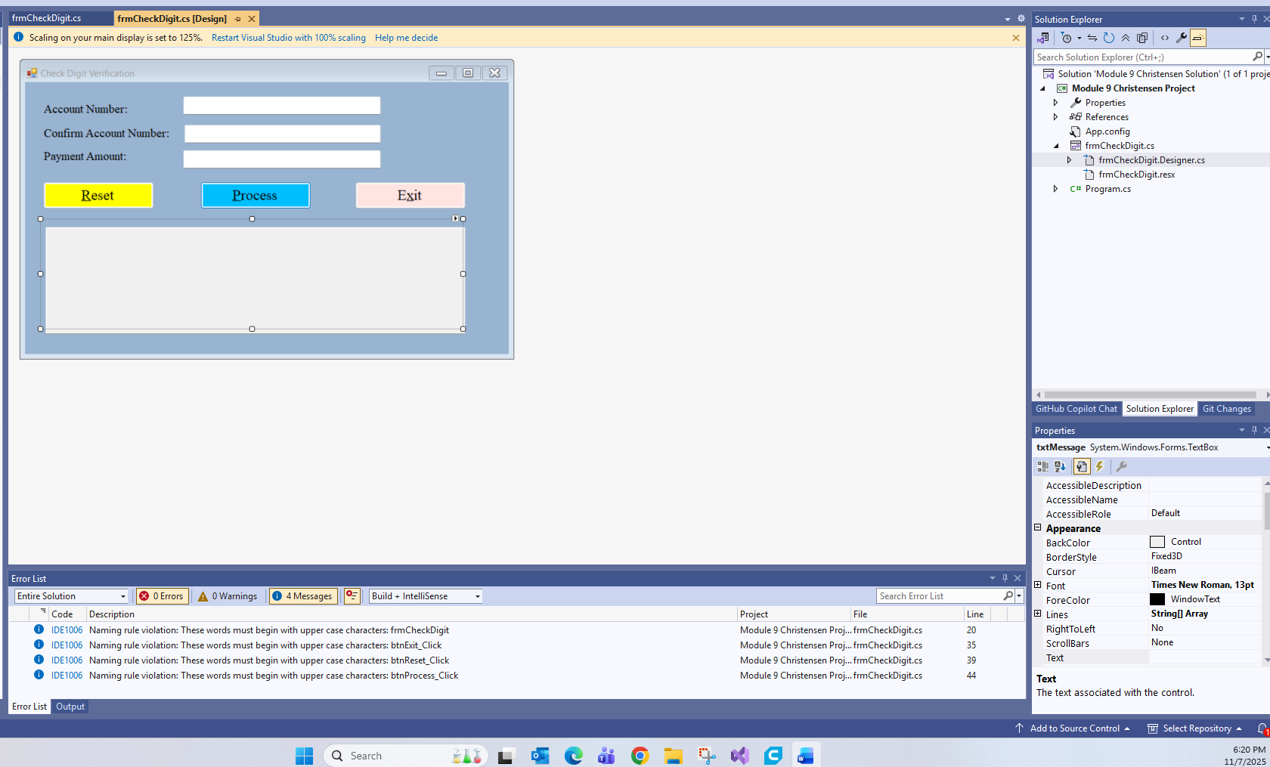

- Run the application in debug mode, screen shot the whole screen showing the form starting up
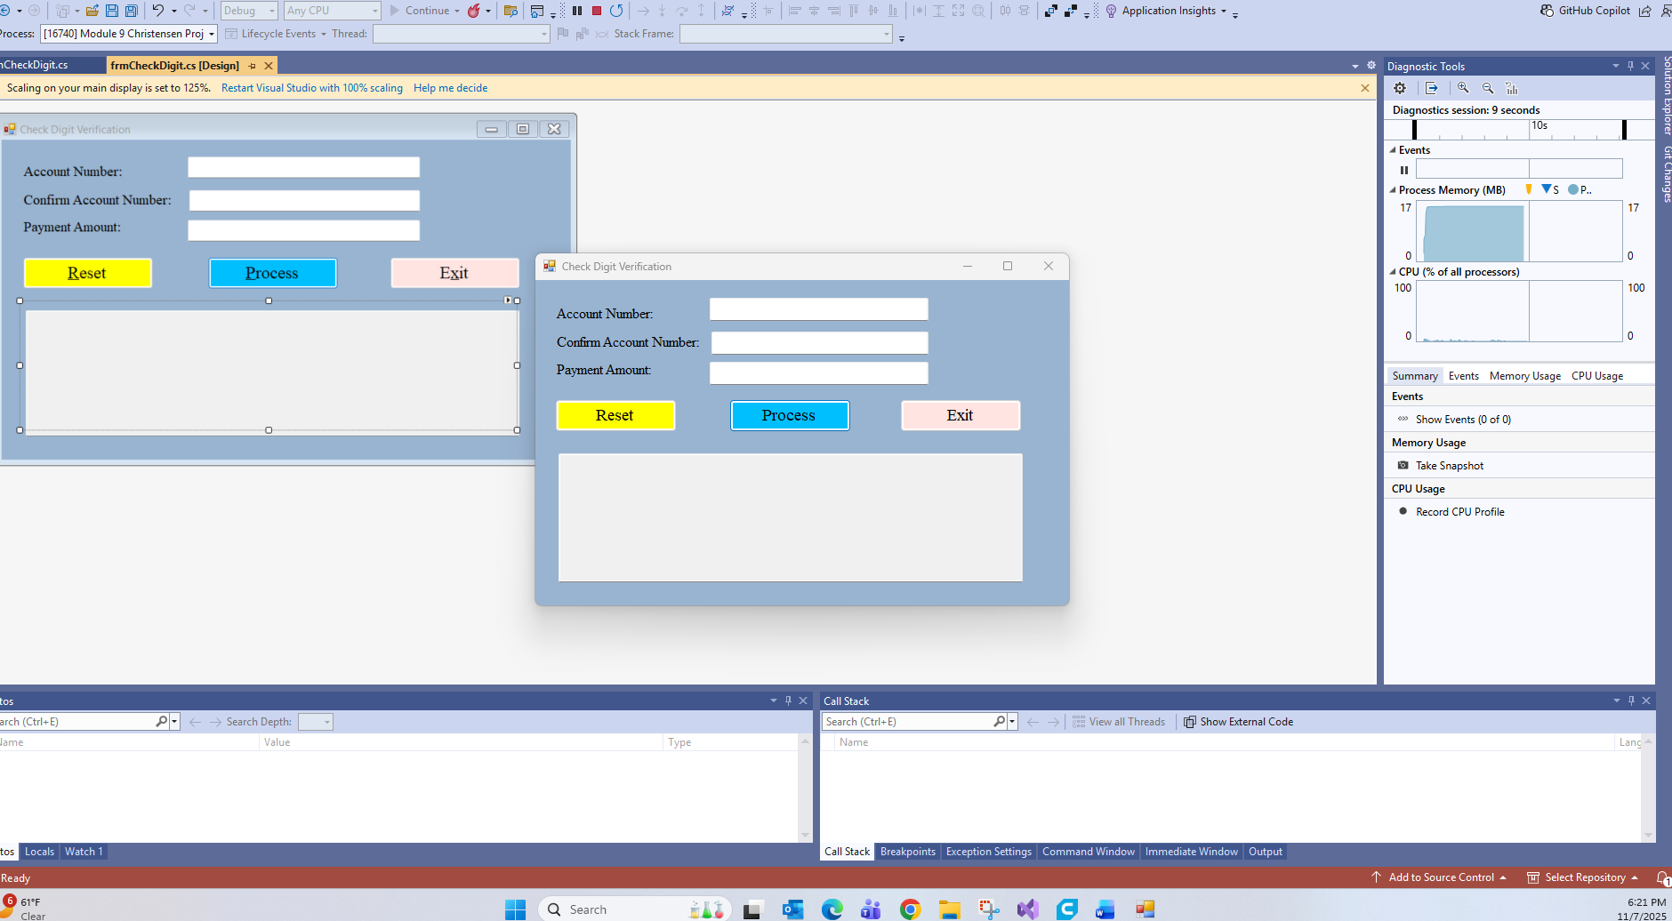

- For the operations screen shots, show one screen shot depicting each of the following scenarios
- Make the following screen shots of the results of the following test cases
  - Running the application with a valid account number
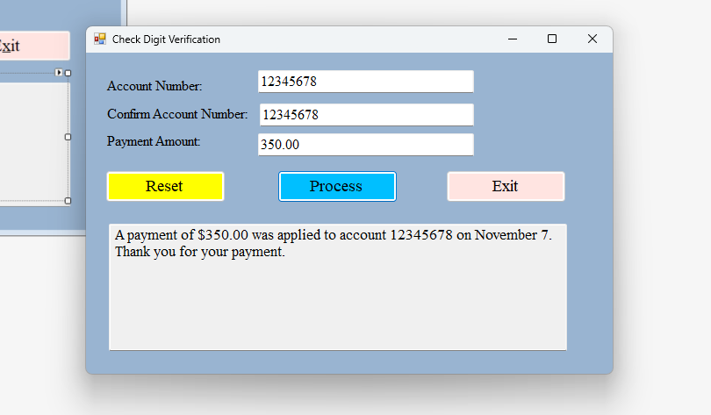

  - Running the application with an invalid account number
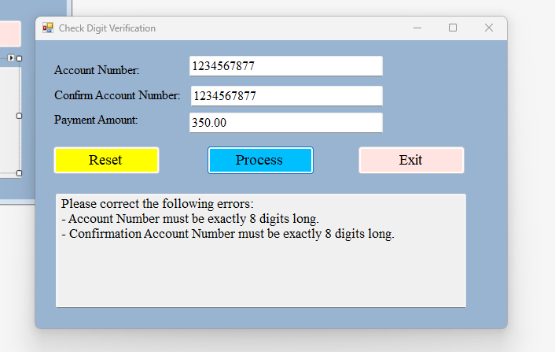

  - Running the application with non-numeric values and/or empty values
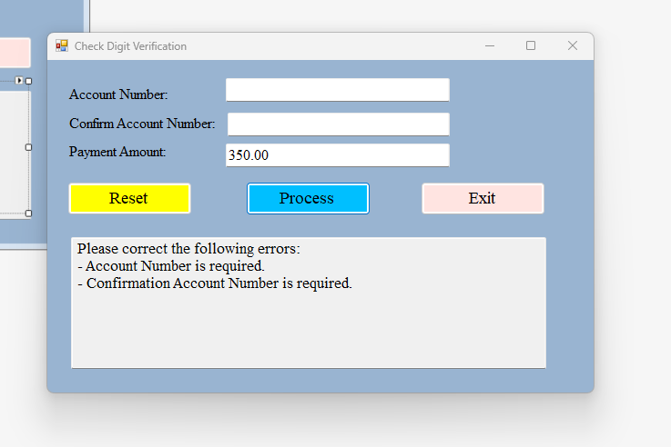

  - Running the application with non-matching account/confirmation values
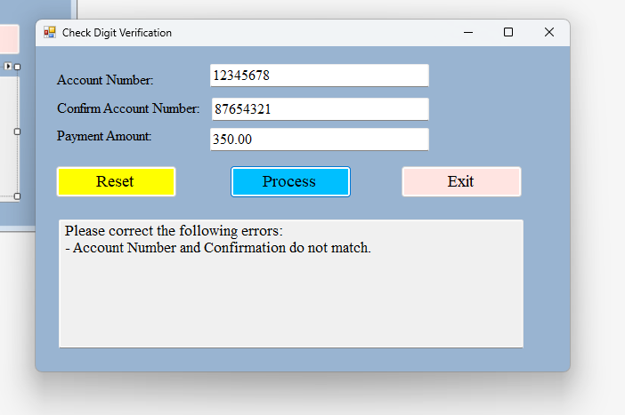

  - Running the application with the payment in a non-standard way ($10,0.01), and show that it's still working properly
